**Problem :** [**https://leetcode.com/problems/longest-increasing-path-in-a-matrix/**](https://leetcode.com/problems/longest-increasing-path-in-a-matrix/)

**Approach :**

->If we imagine edges from nodes to it’s adjacent nodes which has greater values than them , the grid seems like a Directed graph .

-> Just do a DFS from each node,go to it’s adjacent node only if it has a greater value.

So when DFS of a node completes,it would have travelled all Paths which have Increasing Path,and we can store Length of longest increasing path length from a node whose DFS has completed , in a 1-D dp table, so when if we ever visit this node again, we can directly return from DP table.

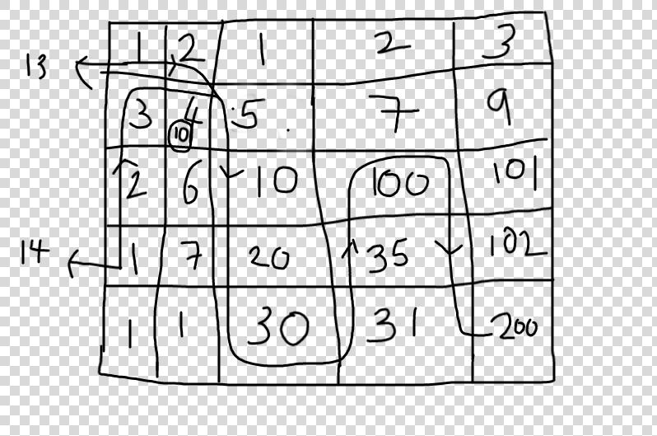

-> If you see when 4 was called from 2, it was discovered that LIP length from 4 was 10, and when it was called from 3, 10was directly returned and used.

**-> Bcoz every Node is traversed only once , Time is O(n) , Space is O(n^2).**

**Code :** [**https://leetcode.com/problems/longest-increasing-path-in-a-matrix/submissions/**](https://leetcode.com/problems/longest-increasing-path-in-a-matrix/submissions/)